

OPERATING & SAFETY MANUAL
BG Snap Assembly Machine
Indo-MIM Pvt Limited | Tata Electronics, Hosur
Document Title | Operating & Safety Manual — BG Snap Assembly Machine
Document Number | IndoMIM-BGSnap-OSM-001
Revision | V5.0
Date | May 2026
Prepared By | Certified Safety Professional
Status | Completed
CONFIDENTIAL

TABLE OF CONTENTS
Right-click this area in Word and select Update Field (or press Ctrl+A then F9) to generate the Table of Contents.
1. FRONT MATTER 5
1.1 Document Scope 5
1.2 Intended Audience 5
1.3 General Safety Rules 5
1.4 Signal Word Hierarchy 5
1.5 Revision History 6
1.6 ISO 7010 Safety Signs Used in This Manual 6
2. MACHINE OVERVIEW 7
2.1 Machine Identification 7
2.2 Technical Specifications 7
2.3 Intended Use 7
2.4 Station Layout & Line Configuration 7
2.5 Key Components 8
2.6 Maintenance Access Zones 8
3. HAZARD IDENTIFICATION & RISK ASSESSMENT 10
3.1 Methodology 10
3.2 Hazard Summary 10
3.3 Hazard Narratives 10
3.4 Risk Reduction Hierarchy (ISO 12100) 11
3.5 Applicable Standards 11
3.6 Personnel Categories 11
4. LOCKOUT / TAGOUT (LOTO) PROCEDURES 13
4.1 Energy Isolation Points 13
4.2 LOTO Equipment Required 13
4.3 De-energization Sequence (Tag-Out) 13
4.4 Re-energization Sequence (Tag-In) 14
4.5 Partial Isolation 15
5. EMERGENCY STOP FUNCTION 16
5.1 E-Stop Device Locations 16
5.2 Stop Category 16
5.3 E-Stop Activation Sequence 16
5.4 E-Stop Reset Procedure 17
5.5 What the E-Stop Does NOT Do 17
5.6 Periodic E-Stop Testing 17
6. OPERATING INSTRUCTIONS 19
6.1 Operating Modes 19
6.2 Pre-Start Checklist 19
6.3 Machine Startup Procedure 19
6.4 Normal Operating Cycle 20
6.5 Process Flowchart 20
6.6 Normal Shutdown 21
6.7 Emergency Shutdown 21
7. MAINTENANCE & CARE 22
7.1 Weekly Maintenance 22
7.2 Monthly Maintenance 22
7.3 Six-Monthly Maintenance 23
7.4 Consumables & Spare Parts 24
8. ELECTRICAL SCHEMATIC 25
8.1 Key Electrical Parameters 25
8.2 Electrical Schematic Drawings 25
9. PNEUMATIC SCHEMATIC 26
9.1 Key Pneumatic Parameters 26
9.2 Pneumatic Schematic Drawings 26
10. IPC ALARMS & FAULT CODES 28
10.1 Alarm Priority Levels 28
10.2 IPC Alarm Code List 28
10.3 General Alarm Response Procedure 28
11. SAFETY FEATURES & INTERLOCKS 29
11.1 Safety Architecture 29
11.2 Safety Control System 29
11.3 Safety Device Inventory 29
11.4 Safety Interlock Logic 30
11.5 Safety Function Testing Requirements 31
11.6 Prohibited Actions 31
12. COMPLIANCE & CERTIFICATIONS 33
12.1 International Safety Standards 33
12.2 Indian Standards & Regulations 33
12.3 Component-Level Standards 33
12.4 Compliance Statement 34
12.5 Document Control 34
12.6 Customer Sign-Off 34
APPENDIX A — RESIDUAL RISK SUMMARY38
APPENDIX B — MAINTENANCE LOG TEMPLATE 38
APPENDIX C — LOTO LOG TEMPLATE38

1. FRONT MATTER

1.1 Document Scope
This manual covers the BG Snap Assembly Machine (Project Reference V67) installed at Tata Electronics, MG Road, Hosur, Tamil Nadu 41504, designed and supplied by Indo-MIM Limited. It addresses machine identification, hazard identification, LOTO procedures, emergency stop, operating instructions, maintenance, schematics, IPC alarms, safety features, and compliance. It does not cover design, manufacture, installation, or commissioning.

1.2 Intended Audience
Audience | Sections to Read
All personnel near machine | Sections 1, 2, 3, Appendix A
Machine operators | Sections 1–6, Appendix A
Setup technicians | All sections
Maintenance technicians | All sections — emphasis on Sections 4, 7, 11
EHS / Safety personnel | Sections 3, 4, 5, 11, 12, Appendix A
Management / Auditors | Sections 1, 3, 12, Appendix A

1.3 General Safety Rules
- Untrained personnel must not operate this machine. No exceptions.
- No maintenance inside the guarding envelope without completing full LOTO (Section 4).
- No safety device, interlock, guard, or label may be removed or bypassed without written authorization from Indo-MIM Limited and Tata Electronics EHS.
- All incidents, near misses, and faults must be reported to the shift supervisor and recorded in the maintenance logbook immediately.
- The machine must be operated only within the intended use defined in Section 2.3.
- PPE must be worn at all times during maintenance as specified in Appendix A.
- This manual must remain at the machine and be available to all operators and technicians during their shift.

1.4 Signal Word Hierarchy
Signal Word | Meaning
DANGER | Imminently hazardous — will result in death or serious injury if not avoided.
WARNING | Potentially hazardous — could result in death or serious injury.
CAUTION | Potentially hazardous — may result in minor or moderate injury.
NOTICE | May result in property or equipment damage. No personal injury risk.

1.5 Revision History
Rev | Date | Description | Reviewed By
V1.0 | April 2026 | Initial issue — DFM V1.4 & RA V1.1 basis. Placeholders for site items. All OAs open. | Certified Safety Professional
V3.0 | May 2026 | Site visit updates: single phase supply correction, IPC nomenclature (replaces HMI), E-stop count updated to 11, LOTO corrections, compulsory energy isolation note added, author field corrected to role only. | Certified Safety Professional
V5.0 | June 2026 | Site visit 27 June 2026: electrical supply corrected to single phase throughout; LOTO point LP-05 (KUKA robot controller) formally designated and added to isolation table; Section 10 (Hydraulic Schematic) removed — not applicable; sections renumbered (11→10, 12→11, 13→12); Appendix A (Residual Risk Summary) added with two residual risks: safety door latch bypass (low-coded Keyence GS-51P5) and timer-activated pneumatic vent; Appendix B = Maintenance Log, Appendix C = LOTO Log; schematic file references added (Sections 8.2, 9.2); site photographs incorporated. | Certified Safety Professional

1.6 ISO 7010 Safety Signs Used in This Manual
Code | Description | Used In
W001 | General warning | Secs 1, 3, 6
W003 | Electricity hazard | Secs 3, 4, 8
W017 | Crushing hazard | Secs 3, 5, 6
W019 | Automatic start-up | Secs 3, 6
W028 | Entanglement hazard | Secs 3, 6
P002 | Do not touch | Secs 3, 4
P010 | Do not switch on | Secs 4, 5
M008 | Wear protective gloves | Secs 4, 7, App A
M009 | Wear safety footwear | Secs 4, 7, App A

Refer to Section 12 for the full Liability Disclaimer.
This manual was prepared by Certified Safety Professional, in accordance with ISO 12100:2010, ISO 20607:2019, IEC 82079-1:2019, and IS 4571:2008. Where data was unavailable, gaps are formally recorded as Open Actions — none have been ignored or assumed away. Indo-MIM Limited and Tata Electronics are jointly responsible for final review and verification. All Open Actions must be closed before the machine enters production service.

2. MACHINE OVERVIEW

2.1 Machine Identification
Field | Details
Machine Name | BG Snap Assembly Machine
Project Reference | V67 — BG Snap Assembly Station
Machine Type | Automated Snap & Screw Assembly Line
Manufacturer | Indo-MIM Limited
End User | Tata Electronics
Installation Location | Tata Electronics, MG Road, Hosur, Tamil Nadu — 631604
DFM Reference | BG Snap Assembly DFM V1.4, dated 18-March-2026
Risk Assessment Ref. | Machine Safety Assessment Report V1.1, dated 23-March-2026, by Independent Safety Consultant
Machine Weight | 6 Tonnes (Approx)

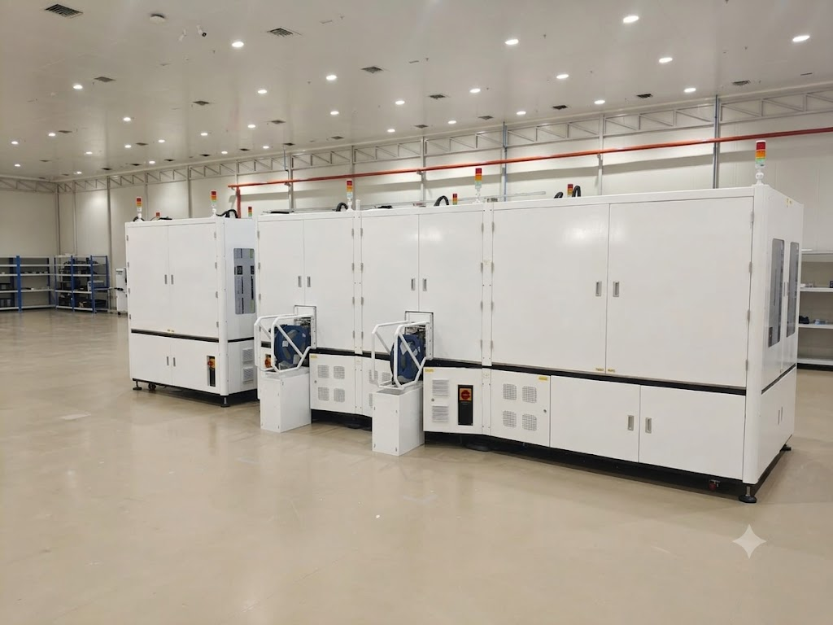

2.2 Technical Specifications
Parameter | Specification
Main Supply | Single Phase, 50 Hz
Station Supply | 220V AC per station
Total Connected Power | 108 kW (full line)
Maximum Current | 523.2 A
Compressed Air | 0.5 – 0.7 MPa (clean, dry, oil-free)
Line Dimensions (L×W×H) | 8,400 mm × 2,100 mm × 2,200 mm
Operator Headcount | 1 (tray loading and unloading only)
Cycle Time | 5 seconds per piece
UPH | 629
OEE | 87.42% (Avail: 93.04% / Perf: 97.03% / 1PY: 96.84%)
Design Life | 10 years (with scheduled maintenance)
Operating Environment | Indoor, controlled temperature & humidity, clean-room-like

2.3 Intended Use
This machine assembles three snap components (part numbers 613-31681, 613-38625, 613-38626) onto each HSG unit, securing each snap with two screws — six screws per unit, every five seconds. Any use outside this scope is foreseeable misuse and is strictly prohibited.

2.4 Station Layout & Line Configuration
Station | Name | Function | Key Equipment
S1 | Loading Machine | Picks HSG from input tray, scans barcode, transfers into Maglev fixture | KUKA KR13 R850, barcode scanner, Cognex
S2 | Snap Assembly & Screwing | Assembles 1st snap; fastens 2 screws; CCD vision recheck | HIWIN axes, Atlas QMC-21, Deprag feeder, YIG reel feeder
S3 | Snap Assembly & Screwing | Assembles 2nd snap; fastens 2 screws; CCD vision recheck | Same as S2
S4 | Flipping Station | Flips HSG 180° to expose reverse face for 3rd snap. Returned to home position. | Rotating cylinder, HIWIN Z-axis, pneumatic unlock
S5 | Snap Assembly & Screwing | Assembles 3rd snap on reverse face; fastens 2 screws; CCD vision recheck | Same as S2/S3
S6 | Unloading Machine | Picks completed HSG; routes OK to output tray; NG to buffer/NG tray | KUKA KR13 R850, buffer fixture, NG tray

Fixture transport: Product fixtures circulate on the Beckhoff Maglev conveyor — upper layer S1→S6, lower layer return. RFID readers (Pepperl+Fuchs IQT1-18GM-IO-V1) at each station link the HSG barcode to fixture ID for full traceability.

2.5 Key Components
Component | Brand & Model | Station(s)
4-axis SCARA Robot | KUKA KR13 R850 Z200-2 CS | S1, S6
Smart Screwdriver | Atlas Copco QMC-21-10-HM4 | S2, S3, S5
Screwdriver Controller | Atlas Copco MTF6000 | S2, S3, S5
Screw Feeder | Deprag Mini Screw Feeder | S2, S3, S5
Tape Reel Feeder | YIG Tape Reel Feeder | S2, S3, S5
Maglev Conveyor | Beckhoff / Baeyal-Golytec | Full line
Servo Axes | HIWIN KK / Toyo GTH series | All stations
Safety PLC | FLX3 series | Full line
Safety Door Latch | Keyence GS-51P5 (PLe / Cat 4 / SIL3) | S1–S6
Safety Light Curtain | Keyence GL-VM39FP (PLe / Cat 4 / SIL3) | S1, S6
IPC & Motion Card | Advantech IPC 7132 + PCIE-1203 | All stations
RFID Reader | Pepperl+Fuchs IQT1-18GM-IO-V1 | All stations
Barcode Scanner | Cognex | S1
3D Snapshot Sensor | LMI Gocator 3506 | S2, S3, S5

2.6 Maintenance Access Zones
Zone | Clearance | Purpose
Front — S1 and S6 ends | 1,000 mm | HSG tray loading and unloading
Rear of line | 1,000 mm | Snap/screw loading, general maintenance
Between S2/S3 and S5 | 500 mm minimum | Fixture access and channel maintenance
Top of machine | 1,000 mm above 2,200 mm | Overhead service and cable management

PLACEHOLDER — Machine Layout Diagram (Figure 2-1)
Full line top-view layout (S1–S6, Maglev conveyor path, access zones). Source: DFM V1.4. 300 DPI, max 160 mm wide.

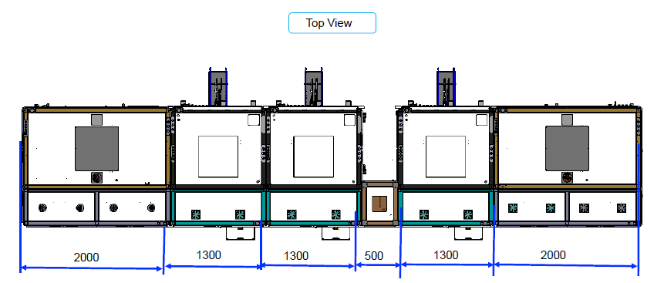

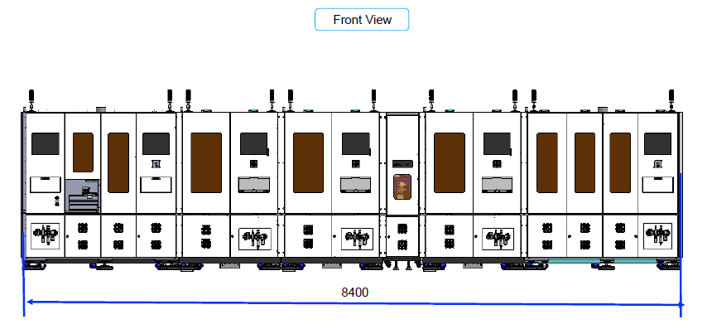

3. HAZARD IDENTIFICATION & RISK ASSESSMENT

3.1 Methodology
The hazard assessment was conducted at design stage by an Independent Safety Consultant using ISO 12100:2010 methodology, covering all lifecycle phases. Each hazard was scored on Severity (S), Exposure (E), and Avoidance (A) to produce a risk level. Risk reduction was applied until all residual risks reached Low. The formal Machine Safety Assessment Report (V1.1, 23-March-2026) is held by Indo-MIM Limited and Tata Electronics.

3.2 Hazard Summary
Category | Hazards Identified | Initial Risk | Residual Risk
Mechanical | 10 | Medium | Low (all)
Electrical | 4 | High (3) / Medium (1) | Low (all)
Ergonomic | 2 | Low | Low (all)
Control System | 4 | High (3) / Low (1) | Low (all)
Chemical | 0 | Not applicable | Not applicable
Total | 20 | — | All Low

3.3 Hazard Narratives
3.3.1 Mechanical Hazards
Shearing from multi-axis servo gantries during maintenance. Entanglement and pinch at rotating fixtures, winder assemblies, and KUKA robot EOAT. Impact and trapping from KUKA SCARA arms and shuttle transfers. Gravity-assisted crushing at vertical lifting actuators. Controls: fixed perimeter guarding, interlocked access doors, STO on all servo drives.
3.3.2 Electrical Hazards
523.2V AC, Single Phase, [PLACEHOLDER — confirm current rating] in electrical enclosures and servo drive cabinets. Hazard types: contact with live parts, shock from insulation failure, residual stored energy, and overheating. Controls: enclosed panel design, lockable main isolator LP-01, protective earthing, LOTO (Section 4).
3.3.3 Ergonomic Hazards
Manual tray loading and unloading at S1 and S6. Awkward posture and physical strain from tray weight and frequency. Assessed Low risk. Managed through operator training and correct work posture guidance (Section 6).
3.3.4 Control System Hazards
Unexpected start-up, hazardous motion with doors open, incorrect reset logic, and safety function bypass. All require PLd/PLc control functions per ISO 13849-1:2015, implemented through the Safety PLC (Section 11).

3.4 Risk Reduction Hierarchy (ISO 12100)
Step | Measure Applied
1 — Inherently Safe Design | Enclosed station housings, Maglev conveyor routing, and single-point operator interaction at defined loading/unloading zones minimize access to hazardous zones.
2 — Safeguarding | Keyence GS-51P5 safety door latches (PLe/Cat4/SIL3), Keyence GL-VM39FP light curtains (PLe/Cat4/SIL3), Safety PLC, STO on all servo drives, dual contactors, robot safety per ISO 10218-1.
3 — Information for Use | This manual, safety warning labels, operator training, PPE requirements, and maintenance procedures address residual risks not eliminated by Steps 1 and 2.

3.5 Applicable Standards
Standard | Title | Relevance
ISO 12100:2010 | Safety of Machinery — Risk Assessment and Reduction | All sections
ISO 13849-1:2015 | Safety-Related Parts of Control Systems | Safety PLC, STO, interlocks, E-stop
ISO 13850:2015 | Emergency Stop Function | E-stop design — Section 5
ISO 14119:2013 | Interlocking Devices for Guards | Safety door latches — Section 11
ISO 14120:2015 | Guards — General Requirements | Fixed and interlocked guard design
ISO 14118:2017 | Prevention of Unexpected Start-Up | Restart prevention — Section 11
ISO 13855:2024 | Positioning of Safeguards | Light curtain positioning
ISO 10218-1:2011 | Safety Requirements for Industrial Robots | KUKA robot integration
ISO 20607:2019 | Instruction Handbook | Manual structure and content
IEC 82079-1:2019 | Preparation of Instructions for Use | Signal word hierarchy
IEC 60204-1:2016 | Electrical Equipment of Machines | Panel design — Section 8
IEC 61496-1:2020 | Electro-Sensitive Protective Equipment | Light curtain spec
IS 4571:2008 | Safety of Machinery (Indian Standard) | Indian regulatory compliance
IS 12100:2012 | Risk Assessment — Indian Adoption | Indian standards framework
Factories Act 1948 | Indian Industrial Labour Law | Statutory compliance — Section 21

3.6 Personnel Categories
Category | Permitted Tasks | Training Required
Operator | Tray loading/unloading, IPC monitoring, alarm acknowledgement, normal cycle start/stop | Machine-specific operator training per this manual
Setup Technician | Recipe selection, parameter adjustment via IPC, fixture changeover | Operator training + setup/changeover training
Maintenance Technician | Scheduled and corrective maintenance, component replacement, LOTO execution | Operator + maintenance training + LOTO certification
Safety / Authorized Person | Safety PLC parameters, safety function testing, RA review | All above + safety system authorization
Manufacturer's Service Engineer | Robot programming, servo parameters, safety PLC config | Manufacturer authorization only

WARNING [ISO 7010 W001]
Residual Risk: Safeguards reduce risk — they do not eliminate it. Residual risks remain manageable only if LOTO is followed, PPE is worn, and procedures are respected. Read Appendix A before your first shift.

4. LOCKOUT / TAGOUT (LOTO) PROCEDURES
Complete LOTO before entering the machine guarding envelope for any maintenance, repair, cleaning, inspection, or fault-clearing activity. No exceptions for quick jobs or familiar tasks.

4.1 Energy Isolation Points
LOTO ID | Energy Type | Description | Isolation Device | Location
LP-01 | Electrical | 523.2V AC, Single Phase, [PLACEHOLDER — confirm current rating] main supply | Lockable rotary main isolator | Main electrical panel — right side of S1
LP-02 | Pneumatic | 0.5–0.7 MPa compressed air | Solenoid valve + lockout hasp | Air inlet — rear of machine base, S1 end
LP-03 | Electrical (Servo) | STO — all HIWIN and Toyo axes | STO command via Safety PLC | Integrated in Safety PLC
LP-04 | Electrical (Maglev) | Maglev linear motor supply | Maglev conveyor PLC isolator | Maglev control panel — centre of line
LP-05 | Electrical (KUKA Robots) | KUKA robot controller main switches (S1 and S6 robot controllers) | Lockable main switch on each robot controller cabinet | S1 and S6 robot controller cabinets — front of each station

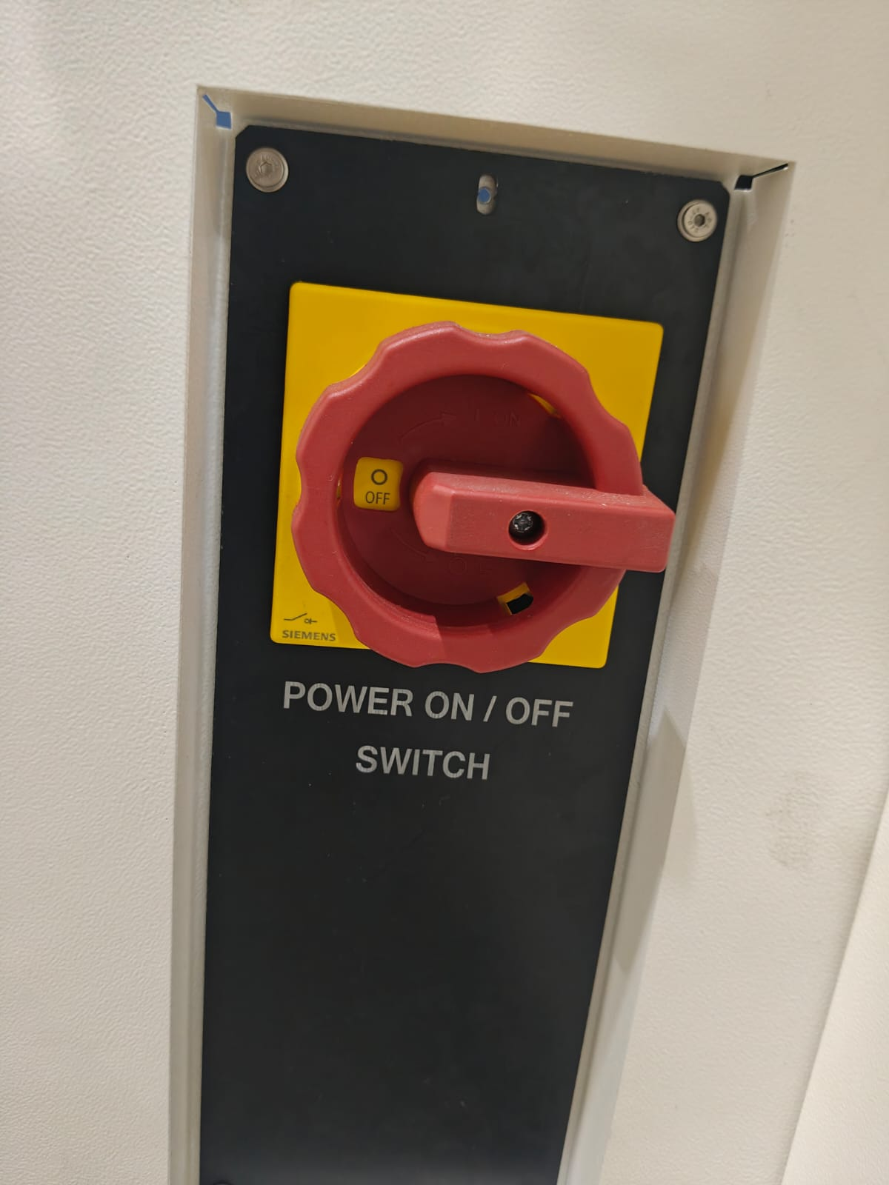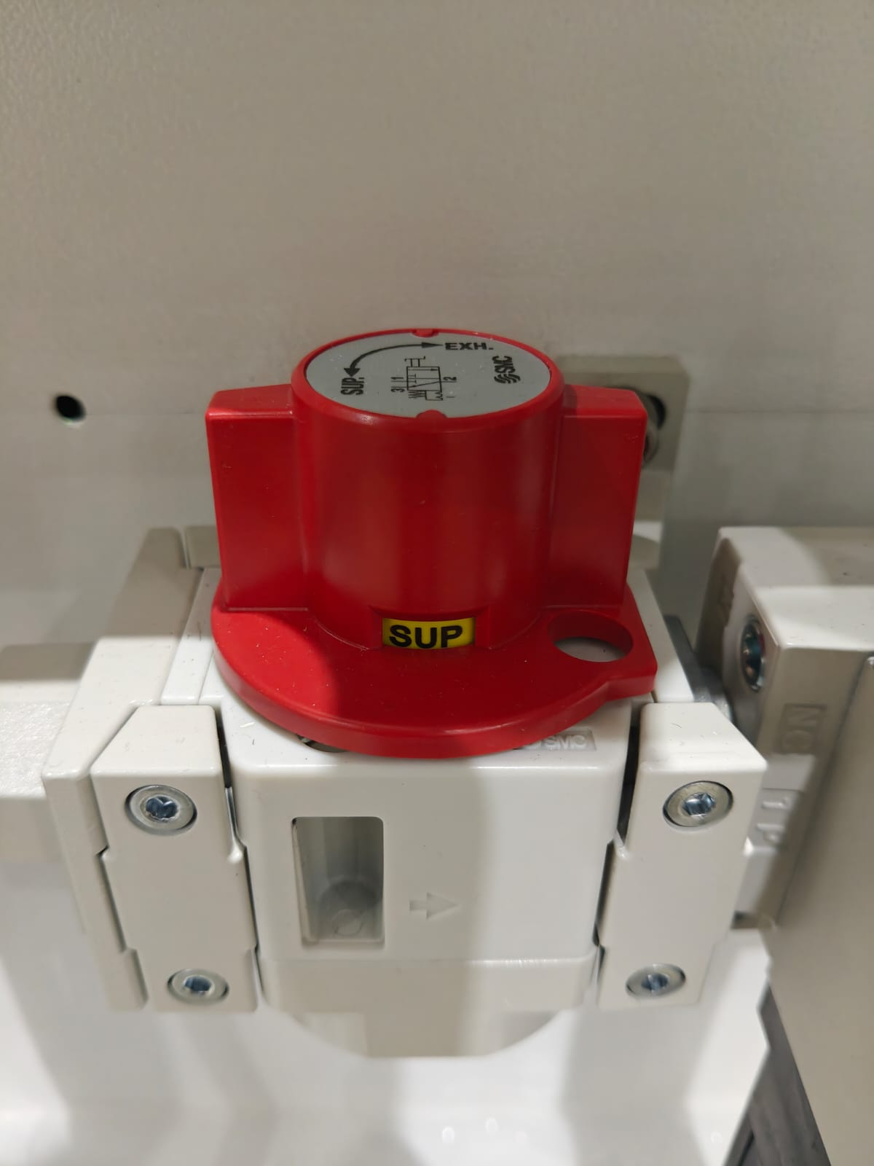

4.2 LOTO Equipment Required
- Personal padlock — one per technician, keyed differently from all others
- Lockout hasp — multi-lock capable, for LP-01 and LP-02
- Danger tag — pre-printed with technician name, date, time, reason
- Calibrated voltage tester — for LP-01 isolation verification
- Pneumatic pressure gauge — to verify LP-02 bleed-down to zero
- LOTO log sheet — to record all isolation activities

4.3 De-energization Sequence (Tag-Out)
Pre-condition: Machine in stopped state, all cycles complete. Follow steps in exact order.
Step 1 — Notify: Inform all personnel in the vicinity. Confirm no person is inside the guarding envelope.
Step 2 — Stop the Machine: Press IPC STOP. Confirm all axes and robots have stopped and active alarms acknowledged.
Step 3 — Select Maintenance Mode: At IPC, select Maintenance Mode. Disables automatic cycle initiation from all stations. NOTE: Compulsory energy isolation (full LOTO per Section 4) is required before any personnel enter guarded zones, even in Maintenance Mode.
Step 4 — Isolate LP-01 (Main Electrical): Turn main rotary isolator to OFF. Apply personal padlock through hasp. Attach Danger tag.
Step 5 — Verify LP-01 Isolation: Using calibrated voltage tester, verify voltage absent at main panel incoming terminals and servo drive inputs. Do not proceed if voltage detected.
Step 6 — Isolate LP-02 (Compressed Air): Close LP-02 ball valve. Apply padlock and tag. Wait for downstream pressure to bleed. Confirm gauge reads zero before proceeding.
Step 7 — Verify LP-02 Isolation: Confirm pressure gauge reads 0 MPa. Attempt to actuate a pneumatic cylinder — no movement must occur.
Step 8 — Isolate LP-05 (KUKA Robots): At each robot controller (S1 and S6), turn main switch to OFF. Dock robot controller. Apply personal padlock to controller cabinet door hasp.
Step 9 — Isolate LP-04 (Maglev): Turn Maglev conveyor PLC isolator to OFF. Confirm movers are stationary and status indicator shows de-energized.
Step 10 — Confirm LP-03 STO Status: Verify Safety PLC confirms STO active on all servo drives. All servo drive enable indicator lights must be off.
Step 11 — Allow Stored Energy to Dissipate: Wait 60 seconds after LP-01 isolation. Servo drive DC bus capacitors hold charge sufficient to cause a serious shock — this wait is mandatory.
Step 12 — Record in LOTO Log: Record technician name, date, time, all points locked out, reason, and signature.
WARNING [ISO 7010 P010]
Your padlock. Your lock. Your life. No one else's padlock protects you. If you are inside the machine, your lock must be on every isolation point — regardless of who else has locked out.

4.4 Re-energization Sequence (Tag-In)
Pre-condition: All maintenance complete. All tools and materials removed. All guards and covers reinstalled and fastened.
Step 1 — Inspect and Clear: Walk full perimeter. Verify no tools or parts inside machine. Confirm all guards in place, access doors closed, no person inside.
Step 2 — Notify All Personnel: Inform all personnel machine is being re-energized. Ensure all are clear.
Step 3 — Restore LP-04 (Maglev): Turn Maglev PLC isolator to ON. Remove padlock and Danger tag from LP-05.
Step 4 — Restore LP-05 (KUKA Robots): Turn controller main switch to ON. Remove padlock. Allow boot sequence to complete.
Step 5 — Restore LP-02 (Compressed Air): Remove padlock and tag. Slowly open ball valve. Verify pressure builds to 0.5–0.7 MPa.
Step 6 — Restore LP-01 (Main Electrical): Remove padlock and tag. Turn main rotary isolator to ON. Verify panel indicator lights confirm power restored.
Step 7 — Confirm Safety System Status: Confirm Safety PLC reports all functions healthy. Test each access door interlock — machine must not allow cycle start with any door open.
Step 8 — Reset and Return to Normal Mode: Exit Maintenance Mode, select Normal Operating Mode. Perform a dry run cycle without product.
Step 9 — Record in LOTO Log: Record re-energization: technician name, time, confirmation all points restored, signature.

4.5 Partial Isolation
Partial isolation is only permitted with written authorization from the Indo-MIM maintenance supervisor and Tata Electronics safety representative, with a station-specific LOTO procedure documented and approved, a LOTO-certified technician performing the work, and a second authorized person present as safety observer at all times.
WARNING [ISO 7010 W001]
Partial isolation increases residual risk significantly. Never performed by a single person working alone. Never used as a routine shortcut to avoid full LOTO.

5. EMERGENCY STOP FUNCTION
The E-stop is a last resort — not a pause button, not a production stop, and not a substitute for LOTO. Use it when something unexpected is happening and you need everything to stop immediately. For planned maintenance, use LOTO.
Designed in accordance with ISO 13850:2015 — Emergency Stop Function — Principles for Design.
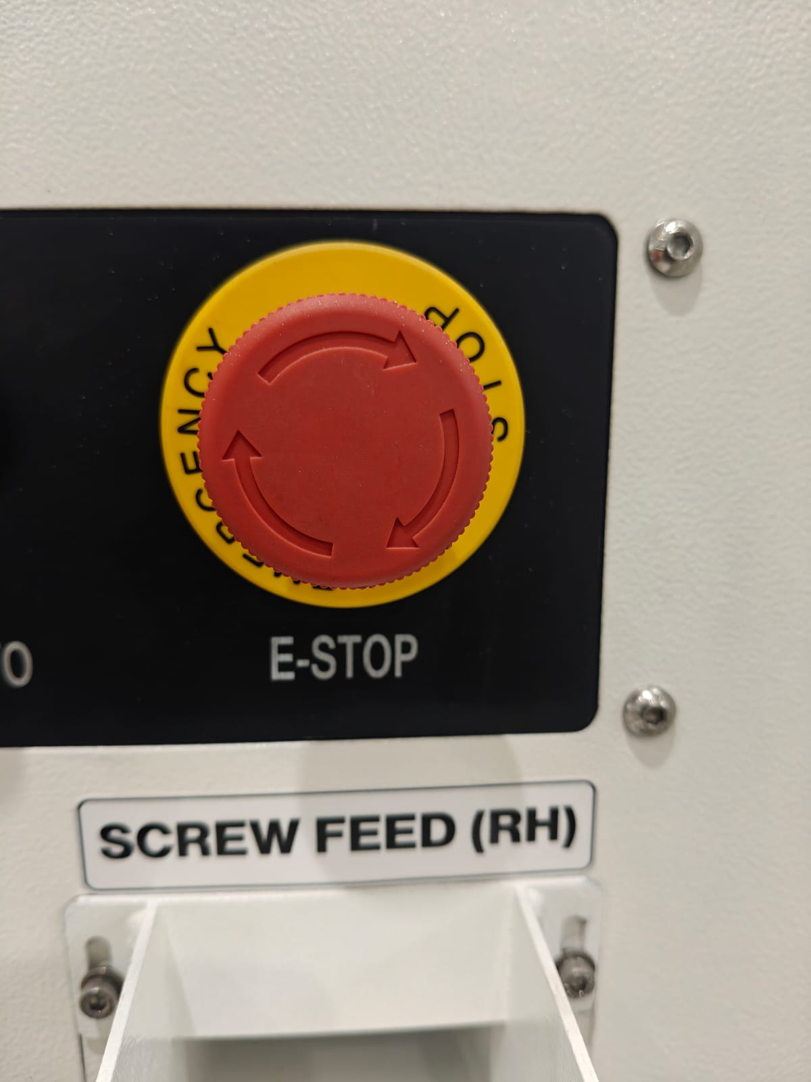

5.1 E-Stop Device Locations
E-Stop ID | Location | Station | Access
ES-01 | IPC control panel — left side | S1 Loading Machine | Front of machine
ES-02 | IPC control panel — left side | S2 Snap Assy & Screwing | Front of machine
ES-03 | IPC control panel — left side | S3 Snap Assy & Screwing | Front of machine
ES-04 | Flipping station control panel | S4 Flipping Module | Front of machine
ES-05 | IPC control panel — left side | S5 Snap Assy & Screwing | Front of machine
ES-06 | IPC control panel — left side | S6 Unloading Machine | Front of machine
ES-07 | [PLACEHOLDER — location TBC: site visit confirmation required] | [PLACEHOLDER] | [PLACEHOLDER]
ES-08 | [PLACEHOLDER — location TBC: site visit confirmation required] | [PLACEHOLDER] | [PLACEHOLDER]
ES-09 | [PLACEHOLDER — location TBC: site visit confirmation required] | [PLACEHOLDER] | [PLACEHOLDER]
ES-10 | [PLACEHOLDER — location TBC: site visit confirmation required] | [PLACEHOLDER] | [PLACEHOLDER]
ES-11 | [PLACEHOLDER — location TBC: site visit confirmation required] | [PLACEHOLDER] | [PLACEHOLDER]

5.2 Stop Category
Category 1 Stop (IEC 60204-1:2016) — controlled deceleration to standstill, then power removal. Selected because high-speed servo axes and KUKA robots require controlled deceleration to prevent mechanical damage and secondary hazards.

5.3 E-Stop Activation Sequence
(1) Signal transmitted to Safety PLC via dual-channel hardwired circuit. (2) All HIWIN and Toyo axes decelerate to standstill under controlled braking. KUKA robots execute Category 1 stop per ISO 10218-1. (3) STO applied to all servo drives once standstill reached. Maglev conveyor de-energized. (4) Pneumatic system moves to fail-safe state. (5) All five IPC stations display E-stop active alarm with station identifier.

5.4 E-Stop Reset Procedure
The E-stop function is latching — cannot be reset remotely or automatically. Follow all steps.
WARNING [ISO 7010 W019]
The machine will move on restart. Before pressing RESET, walk the machine and identify why the E-stop activated. If you cannot identify the cause, do not reset — call the maintenance technician.

Step 1 — Identify Cause: Walk full machine perimeter. Identify reason. Resolve any hazardous condition. Confirm all personnel clear.
Step 2 — Release E-Stop Pushbutton: At the activated station, rotate mushroom-head pushbutton clockwise until released. Cannot be released from IPC.
Step 3 — Acknowledge Alarm at IPC: At the station IPC, acknowledge the E-stop alarm. Confirm no other active alarms before proceeding.
Step 4 — Confirm Safety System Status: Confirm Safety PLC reports all safety functions healthy. All door interlocks engaged. Light curtains unobstructed.
Step 5 — Restart Authorization: Only authorized operator or technician may authorize restart. Must be initiated from IPC.
Step 6 — Initiate Controlled Restart: Press RESET then CYCLE START. Machine performs controlled homing before resuming operation. Monitor first cycle carefully.
Step 7 — Record E-Stop Event: Record in maintenance log: station, time, cause, corrective action, name of person who reset.

5.5 What the E-Stop Does NOT Do
- Does not isolate the 523.2V AC main electrical supply — the main panel remains energized.
- Does not immediately vent all pneumatic pressure — residual pressure may remain.
- Does not substitute for LOTO — never use E-stop as a lockout device for maintenance.
Does not prevent re-energization by another person — apply your personal LOTO padlock when entering.

5.6 Periodic E-Stop Testing
Test | Frequency | Acceptance Criteria
Daily (once per shift) | Operator activates each accessible E-stop button. Machine must enter safe state. Reset and confirm normal operation resumes before production starts. | Operator
Functional test — all E-stop buttons | Weekly | All axes stop, STO applied, IPC alarm displayed, no auto-restart
Dual-channel integrity test | Monthly | Safety PLC fault alarm within 500 ms on channel disconnect
Response time verification | Six-monthly | Standstill achieved within manufacturer-specified deceleration time
Full safety function audit | Annually | All safety functions verified to PLd/Category 3 per ISO 13849-1

6. OPERATING INSTRUCTIONS
During automatic operation your role is: load trays at S1, collect trays at S6, monitor the IPC. Do not interfere with the automatic cycle. If something looks wrong, press E-stop and call the technician.

6.1 Operating Modes
Mode | Description | Who Can Select
Automatic | Full automatic assembly cycle. Runs continuously.  Screw loading on assembly station  Snap-loading, Reel loading | Trained Operator
Manual | Individual station/axis movements one step at a time. Setup, changeover, troubleshooting only. | Setup Technician or above
Maintenance | All automatic functions disabled. Used with LOTO during maintenance. | Maintenance Technician or above

6.2 Pre-Start Checklist
# | Check Item | Required Condition
1 | All access doors and safety guards | Fully closed and latched
2 | All E-stop pushbuttons ES-01 to ES-06 | Released — buttons in extended position
3 | Safety light curtains at S1 and S6 | Unobstructed — green indicator active
4 | Compressed air pressure gauge at inlet | 0.5 to 0.7 MPa
5 | Main electrical isolator LP-01 | ON position
6 | All IPC displays | Powered on — no active alarms
7 | KUKA robot controllers S1 and S6 | Powered on — no fault indicators
8 | Maglev conveyor | Powered on — status normal on IPC
9 | Input tray area at S1 | Clear of obstructions — tray loaded with HSG units
10 | Output tray area at S6 | Empty tray in position
11 | Screw feeders S2, S3, S5 | Loaded — feeder level indicator showing adequate supply
12 | Tape reel feeders S2, S3, S5 | Snap tape reels loaded and threaded correctly
13 | LOTO log | No open LOTO entries — machine released from maintenance
14 | Work area around machine | Clear of personnel, tools, and obstructions
15 | Reel Feeder | To ensure all reel feeders in place

6.3 Machine Startup Procedure
Pre-condition: All pre-start checks in Section 6.2 completed.
Step 1 — Power On: Confirm LP-01 in ON position. Confirm all IPC displays showing home screen.
Step 2 — Clear All Alarms: At each IPC (S1–S6), acknowledge and clear residual alarms. Do not proceed if any alarm cannot be cleared.
Step 3 — Initialize Safety System: At S1 IPC, confirm Safety PLC reports all functions healthy. Confirm all door interlocks engaged and light curtains active.
Step 4 — Home All Axes: Select Homing at S1 IPC. Initiate automatic homing sequence. Do not interrupt once started.
Step 5 — Initialize KUKA Robots: Confirm both robots (S1 and S6) show ready status. Contact maintenance if either shows a fault.
Step 6 — Initialize Maglev Conveyor: Confirm Maglev initialized and all fixture movers detected on IPC.
Step 7 — Select Recipe: Navigate to Recipe screen. Select correct product recipe. Confirm name and version match production order.
Step 8 — Select Automatic Mode: Select Automatic Mode at S1 IPC. Confirm mode indicator changes on all station IPCs.
Step 9 — Load Input Tray: Place loaded input tray at S1. Seat in guide rails. Push until clamping jaws engage audibly. Confirm tray detected on IPC.
Step 10 — Start Cycle: Press CYCLE START at S1 IPC. Monitor first cycle to confirm all stations operating normally.

6.4 Normal Operating Cycle
Station | Sequence
S1 — Loading | KUKA robot picks HSG → barcode scan → secondary positioning fixture → Maglev fixture mover. Barcode fail → NG conveyor.
S2 — 1st Snap & Screw | Tape reel advances snap. Voice coil picks snap. CCD pre-inspection. Snap placed at 1st position. Atlas screwdriver drives 2 screws to torque. CCD recheck. Torque or seating NG → screws tossed, HSG flagged.
S3 — 2nd Snap & Screw | Same sequence as S2 for the 2nd snap position.
S4 — Flip | Flipping module suctions HSG, rotates 180°, replaces in fixture with reverse face exposed.
S5 — 3rd Snap & Screw | Same sequence as S2/S3 for 3rd snap on reverse face.
S6 — Unloading | KUKA robot picks completed HSG. OK → output tray. NG at any station → buffer fixture or NG tray.

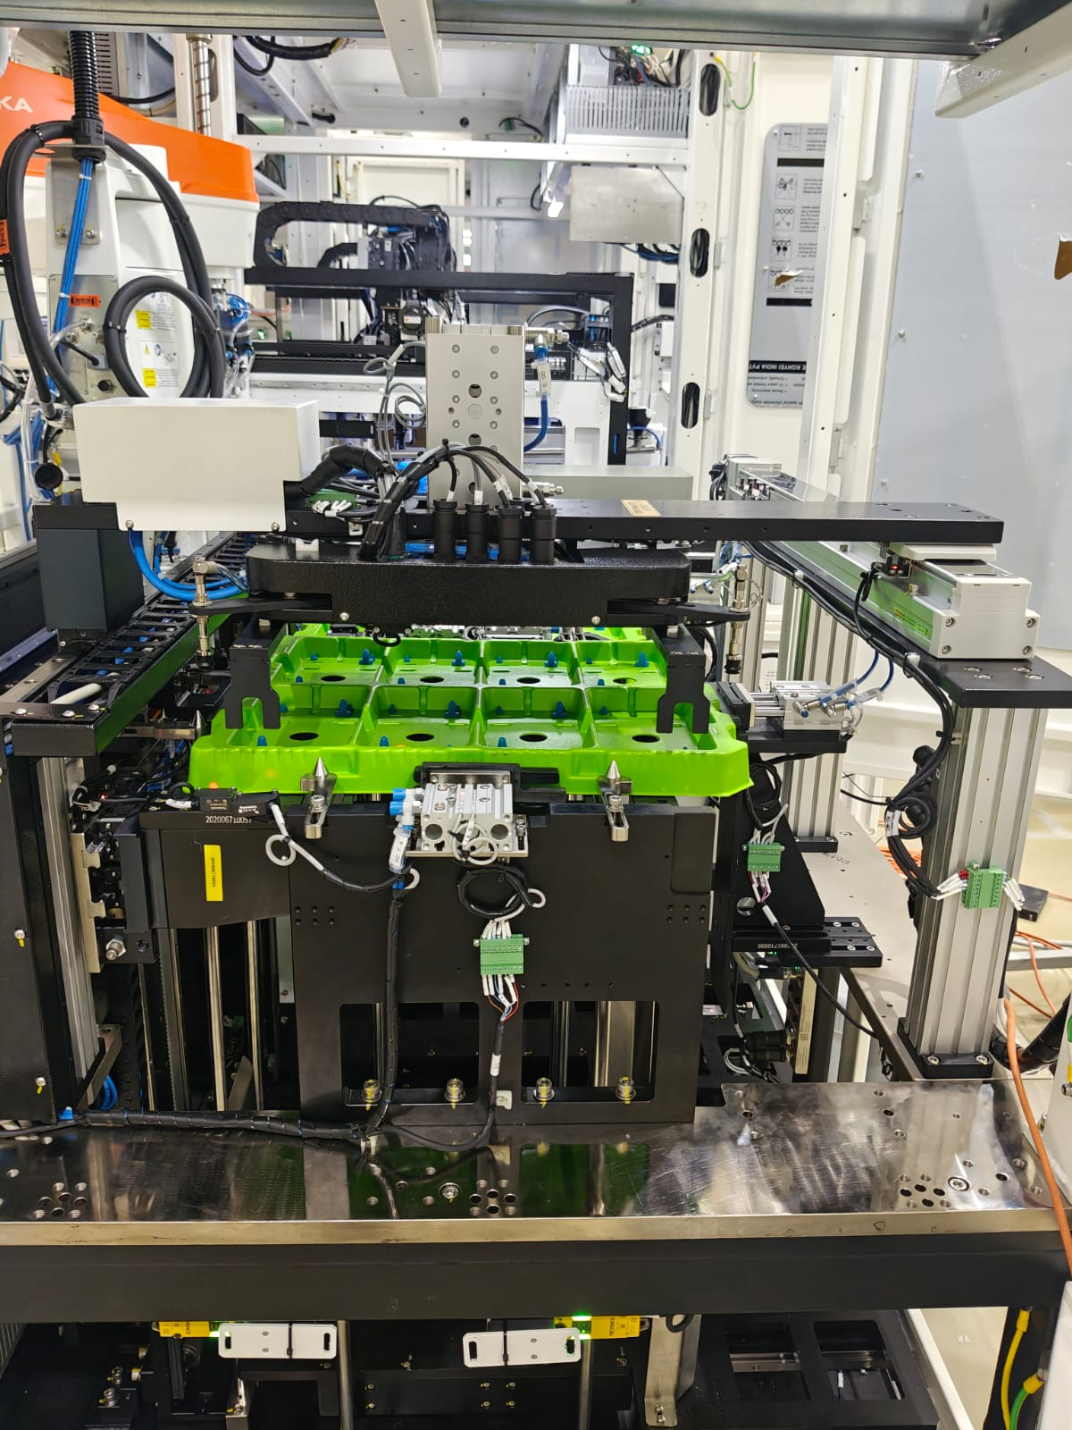

6.5 Process Flowchart
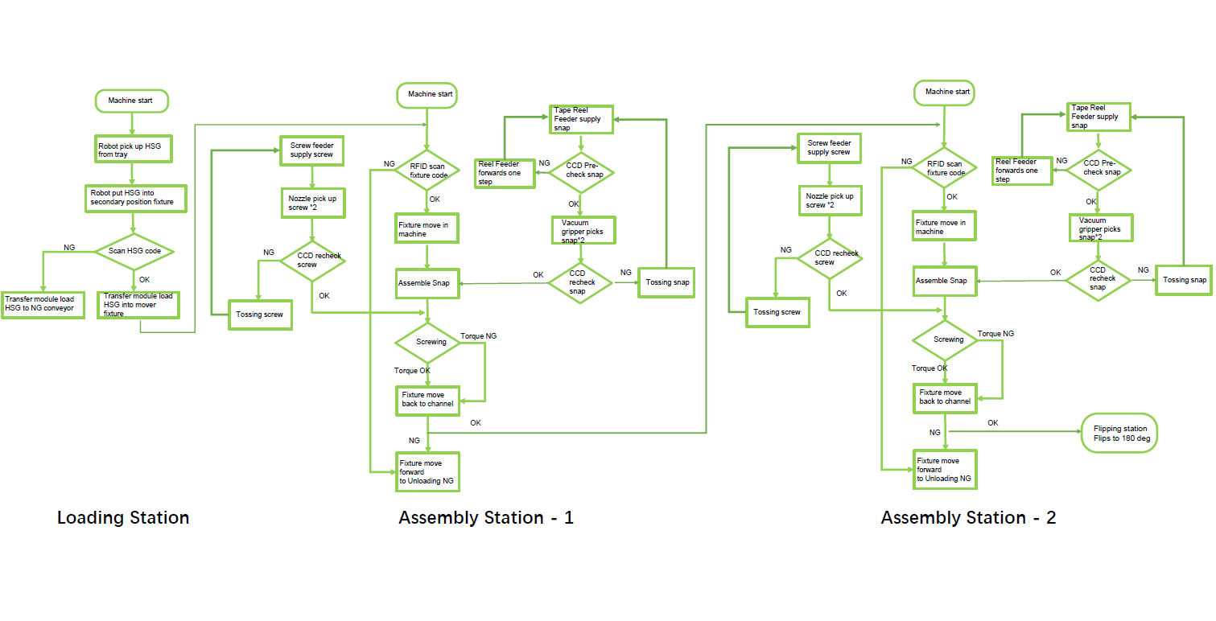

6.6 Normal Shutdown
Step 1 — : Let the current cycle finish. Mid-cycle stops leave partially assembled HSG units requiring manual clearance.
Step 2 — : At S1 IPC, press CYCLE STOP. Machine completes current cycle and comes to a controlled stop.
Step 3 — : Remove input trays from S1, output trays from S6. Remove and segregate NG parts from buffer tray.
Step 4 — : At IPC, select Controlled Shutdown. Machine homes all axes, de-energizes Maglev, powers down robot controllers.
Step 5 — : Once IPC confirms shutdown complete, turn LP-01 to OFF if required by site procedure.
Step 6 — : Record any alarms, faults, or observations in the machine logbook.

6.7 Emergency Shutdown
Use only when an immediate stop is required due to an unsafe condition.
Step 1 — : Press the nearest E-stop (ES-01 through ES-06). Machine executes Category 1 controlled stop.
Step 2 — : Do not attempt to restart until the cause has been identified and resolved.
Step 3 — : Follow E-stop reset procedure (Section 5.4) before returning to service.
Step 4 — : Record the event in the logbook. Report to shift supervisor immediately.

7. MAINTENANCE & CARE
All maintenance must be performed by trained and authorized technicians only. Complete full LOTO (Section 4) before entering the guarding envelope for any task.
WARNING [ISO 7010 P010]
Every task that requires entering the machine requires LOTO first. Stated once here — applies everywhere. No exceptions for quick jobs or familiar tasks.

7.1 Weekly Maintenance
# | Task | Station | LOTO
W-01 | Test all E-stop pushbuttons individually — verify controlled stop and IPC alarm | All | No
W-02 | Inspect all fixed guards and enclosure panels — verify fasteners are tight | All | No
W-03 | Clean CCD camera lenses (upper and lower) — lint-free cloth and approved optical solution only | S2,S3,S5 | ⚠️ LOTO
W-04 | Clean LMI Gocator 3D sensor windows — lint-free cloth only, no solvents | S2,S3,S5 | ⚠️ LOTO
W-05 | Inspect HIWIN/Toyo linear axis rails — remove debris, check for contamination | All | ⚠️ LOTO
W-06 | Inspect KUKA robot EOAT grippers and nozzles — check for wear, damage, or contamination | S1,S6 | ⚠️ LOTO
W-07 | Inspect snap tape reel feeder mechanism — clean feed path, check for tape debris | S2,S3,S5 | ⚠️ LOTO
W-08 | Inspect Deprag screw feeder — clean feed track, check for jammed or deformed screws | S2,S3,S5 | ⚠️ LOTO
W-09 | Inspect Atlas screwdriver nozzles — check for wear and screw seating integrity | S2,S3,S5 | ⚠️ LOTO
W-10 | Inspect Maglev mover carriages — check for debris on rail surface | Full line | ⚠️ LOTO
W-11 | Inspect fixture bodies — check push blocks, datum blocks, clamping surfaces | All | ⚠️ LOTO
W-12 | Check pneumatic tubing and fittings for leaks or damage | All | No
W-13 | Verify RFID reader status at all six stations — confirm correct fixture ID reading | All | No

7.2 Monthly Maintenance
# | Task | Station
M-01 | Lubricate HIWIN linear guide rail blocks — apply recommended grease via grease nipple. See OA-P5-008. | All
M-02 | Lubricate Toyo servo axis ball screw — apply recommended grease. See OA-P5-008. | All
M-03 | Inspect and clean Pepperl+Fuchs RFID reader faces — check mounting and cable condition | All
M-04 | Inspect Keyence safety door latch mechanisms — check latch pin condition and actuator alignment | All
M-05 | Test dual-channel E-stop circuit integrity at Safety PLC input terminals — verify fault alarm within 500 ms | All
M-06 | Check servo drive cooling fan operation — confirm airflow, listen for abnormal noise | All
M-07 | Inspect pneumatic cylinder seals at tray locking and flipping modules — check for air weeping | S1,S4,S6
M-08 | Check Maglev mover wheel condition — inspect for flat spots or uneven wear | Full line
M-09 | Verify Atlas screwdriver torque calibration — run calibration check per Atlas MTF6000. Confirm within ±5% of set value. | S2,S3,S5
M-10 | Inspect IPC/motion card cooling — clean dust filters on Advantech IPC cabinets | All
M-11 | Back up IPC recipe files and PLC program to approved storage location | All
M-12 | Inspect voice coil actuator stroke — verify correct snap pick-up and placement position | S2,S3,S5

7.3 Six-Monthly Maintenance
# | Task | Station | Specialist?
SM-01 | Full safety function audit — verify all PLe/Cat4 safety functions per ISO 13849-1 verification checklist | All | Authorized safety technician
SM-02 | KUKA robot full calibration check — verify TCP, axis positions, and working envelope | S1,S6 | KUKA authorized engineer
SM-03 | Vision system full calibration — all CCD cameras using calibration plate | S2,S3,S5 | Vision-trained technician
SM-04 | LMI Gocator 3D sensor full calibration — using reference target | S2,S3,S5 | Vision-trained technician
SM-05 | Replace Atlas screwdriver nozzles — scheduled replacement regardless of visual condition | S2,S3,S5 | Maintenance technician
SM-06 | Replace fixture push blocks (PU material) — scheduled replacement due to wear | All | Maintenance technician
SM-07 | Full electrical inspection — cable terminations, earth continuity, insulation resistance | All | Qualified electrician
SM-08 | Maglev conveyor full system check — mover positioning accuracy and rail alignment | Full line | Beckhoff authorized technician
SM-09 | E-stop response time verification — measure time from activation to full axis standstill | All | Authorized safety technician

7.4 Consumables & Spare Parts
Item | Station | Replacement Trigger | Min. Stock
Snap components (613-31681, 613-38625, 613-38626) | S2,S3,S5 | Tape reel empty | Per production plan
Screws (M-type per assembly spec) | S2,S3,S5 | Feeder at minimum level | 2-shift supply minimum
Atlas screwdriver nozzle tips (QMC-21-10-HM4) | S2,S3,S5 | Worn / 6-monthly schedule | 4 sets minimum
Fixture push blocks (PU material) | All | Worn or deformed / 6-monthly | 2 sets per station
Fixture datum blocks (PPS) | All | Cracked or out of tolerance | 1 set per station
Tape reel feeder drive belt (YIG compatible) | S2,S3,S5 | Worn or slipping | 2 per feeder type
Safety door latch (Keyence GS-51P5 complete) | All | Latch pin worn / interlock fault | 2 units minimum

8. ELECTRICAL SCHEMATIC
WARNING [ISO 7010 W003]
The main electrical panel operates at 523.2V AC, Single Phase, [PLACEHOLDER — confirm current rating]. Access restricted to authorized electricians only. Complete full LOTO including LP-01 isolation and voltage verification before opening any electrical enclosure.

8.1 Key Electrical Parameters
Parameter | Specification
Main Supply | 523.2V AC, Single Phase, 50 Hz
Maximum Current | [PLACEHOLDER — confirm current rating]
Total Connected Power | 54 kW (full line)
Station Supply | 220V AC per station
Control Voltage | 24V DC (Safety PLC and I/O)
Robot Controller | KUKA KR CS Box-2
Safety PLC | FLX3 series
Motion Control | Advantech IPC 7132 + PCIE-1203 motion card
Communication | EtherCAT (motion), TCP/IP (MES/TRACE), OPC-UA
Main Isolator | Lockable rotary type, [PLACEHOLDER — confirm current rating], main panel
Protection Standard | IEC 60204-1:2016

8.2 Electrical Schematic Drawings
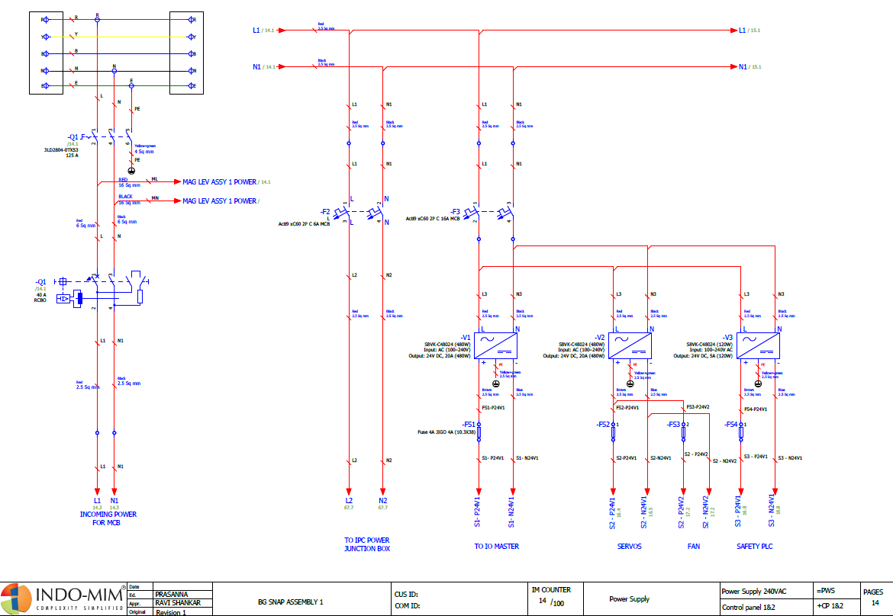
Full Pneumatic Circuit Diagram (Figure 8.2-1) - Diagram: Power Isolator Circuit Diagram

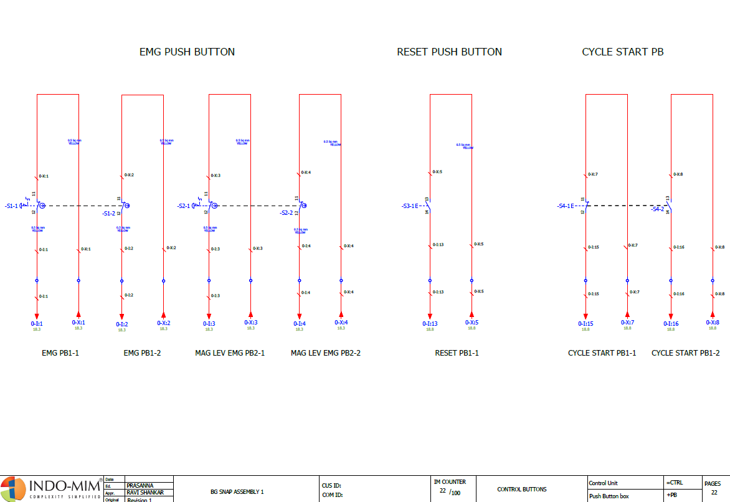
Full Pneumatic Circuit Diagram (Figure 8.2-2) - Diagram: Emergency Stop Circuit Diagram

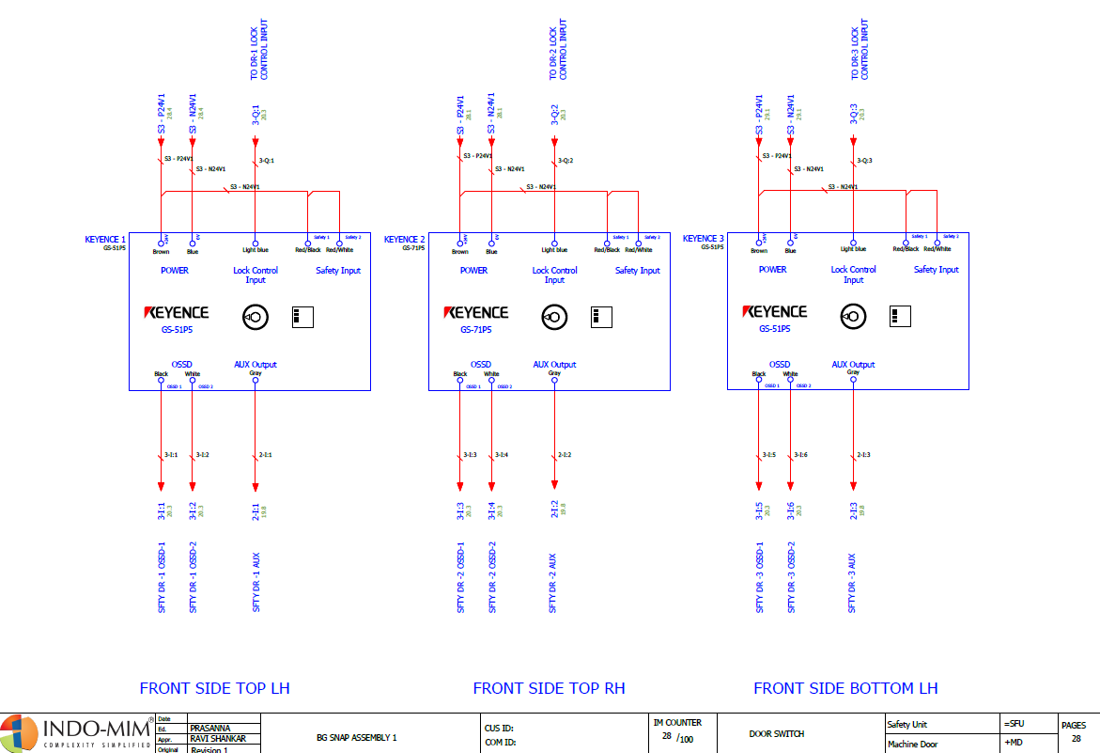
Full Electrical Circuit Diagram (Figure 8.2-2) - Diagram: Door Switch Circuit Diagram
For more details on the electrical schematics, refer to the following reference document held with this manual: BG SNAP ASSEMBLY-1(24-06-2026).pdf
9. PNEUMATIC SCHEMATIC
WARNING [ISO 7010 W017]
Residual pneumatic pressure remains in downstream lines after LP-02 isolation until fully bled down. Always verify pressure gauge reads zero before reaching near any pneumatic actuator.

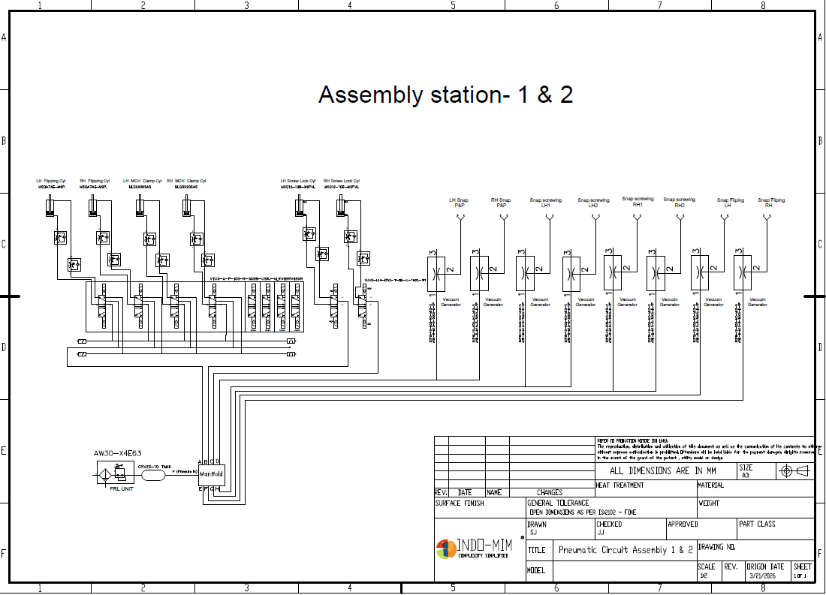

9.1 Key Pneumatic Parameters
Parameter | Specification
Supply Pressure | 0.5 to 0.7 MPa
Air Quality | Clean, dry, oil-free compressed air
Main Isolation | Solenoid valve — de-energise via IPC/control panel; manually verify vent before entry (LP-02)
Actuator Types | SMC and FESTO cylinders — tray locking, flipping, rotating
Solenoid Valves | 24V DC solenoid actuation via Safety PLC I/O
Fail-Safe Design | System dumps to safe state on E-stop activation
Design Standard | ISO 4414 — Pneumatic Fluid Power: Safety Requirements

9.2 Pneumatic Schematic Drawings
PLACEHOLDER — Full Pneumatic Circuit Diagram (Figure 9-1)
Diagram: (1) Main air supply to machine manifold; (2) FRL unit at inlet; (3) Solenoid valve bank all stations; (4) Individual actuator circuits; (5) ISO 1219-1 symbol legend; (6) Pressure settings table. Source: Indo-MIM pneumatic design team. A3 at 300 DPI.

For more details on the pneumatic schematics, refer to the following reference documents held with this manual: Loading Station Pneumatic.pdf; Assembly Station1 & 2 Pneumatic.pdf
10. IPC ALARMS & FAULT CODES
The machine is equipped with five IPC stations (one per major section). All alarms are displayed on the relevant station IPC and simultaneously logged in the SQL-based production database.

10.1 Alarm Priority Levels
Level | Colour | Description | Machine Response
1 — Critical | Red | Safety-related or machine-stopping fault. Immediate attention required. | Machine stops automatically. Cycle cannot restart until alarm resolved.
2 — Warning | Amber | Non-critical condition requiring attention within current shift. | Machine continues. Operator must acknowledge and monitor.
3 — Information | Blue | Operational notification — no immediate action required. | Machine continues. Logged automatically.

10.2 IPC Alarm Code List
PLACEHOLDER — Full IPC Alarm Code Table (Figure 11-1)
Table columns: Alarm Code | Description | Station | Priority (1/2/3) | Probable Cause | Operator Action | Reset Procedure. Source: Indo-MIM software engineering — to be extracted from C# alarm module and SQL alarm table.

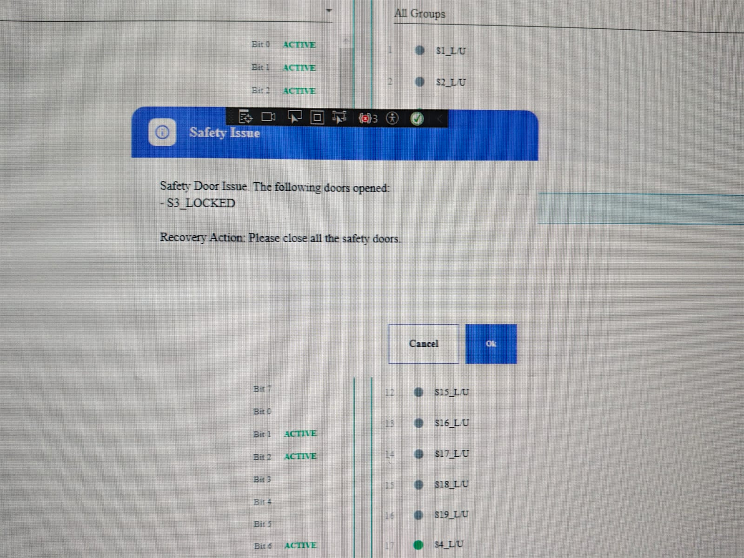
OPEN ACTION [OA-P5-003]
Complete IPC alarm code list has not been provided at the time of preparation of this manual.
Responsibility: Indo-MIM Engineering | Target: Before manual finalization | Status: Open

10.3 General Alarm Response Procedure
Step 1 — Read the Alarm: Note alarm code, description, and station on IPC. Do not acknowledge before understanding the alarm.
Step 2 — Assess Priority: Identify priority level from colour. For Level 1 Critical, stop all manual interaction and contact maintenance.
Step 3 — Do Not Override: Never use Manual Mode or maintenance bypass to override an active alarm without identifying the cause.
Step 4 — Contact Maintenance: For any alarm outside trained knowledge, contact maintenance immediately.
Step 5 — Record the Alarm: Record alarm code, time, and observations in the machine logbook.

11. SAFETY FEATURES & INTERLOCKS
This section documents what is protecting you, how it works, and what happens when it activates. Operators must not modify, bypass, or interfere with any safety device or interlock under any circumstances.

11.1 Safety Architecture
Level | Measure
1 — Inherently Safe Design | Enclosed station housings, Maglev routing, and single operator interaction point at defined loading/unloading zones minimize access to hazardous zones during normal operation.
2 — Fixed Guarding | All stations enclosed within fixed metal guarding panels fastened with tools. Must be reinstalled and fully fastened after any maintenance before return to service.
3 — Interlocked Safeguarding | All access doors interlocked with Safety PLC. Opening any door during operation triggers safety-rated stop. Light curtains at S1 and S6 provide area sensing at operator interaction points.
4 — Complementary Measures | E-stop pushbuttons at all six stations. Warning labels, PPE, operator training, and this manual address residual risks not eliminated by Levels 1–3.

11.2 Safety Control System
Parameter | Details
Safety PLC | FLX3 series — dual-channel, self-monitoring
Standard | ISO 13849-1:2015
Independence | Operates independently from machine software (C#). Machine app fault does not affect Safety PLC.
Safety Outputs | Dual contactor control — servo drives and Maglev conveyor
STO Function | Safe Torque Off on all HIWIN and Toyo servo drives
Robot Interface | KUKA KR CS Box-2 safety I/O — ISO 10218-1 compliant
E-Stop Circuit | Dual-channel hardwired, monitored by Safety PLC
Door Circuit | Dual-channel per door, monitored by Safety PLC
Light Curtain | Direct Safety PLC input — OSSD dual-channel
Diagnostic Coverage | High DC per IEC 62061

11.3 Safety Device Inventory

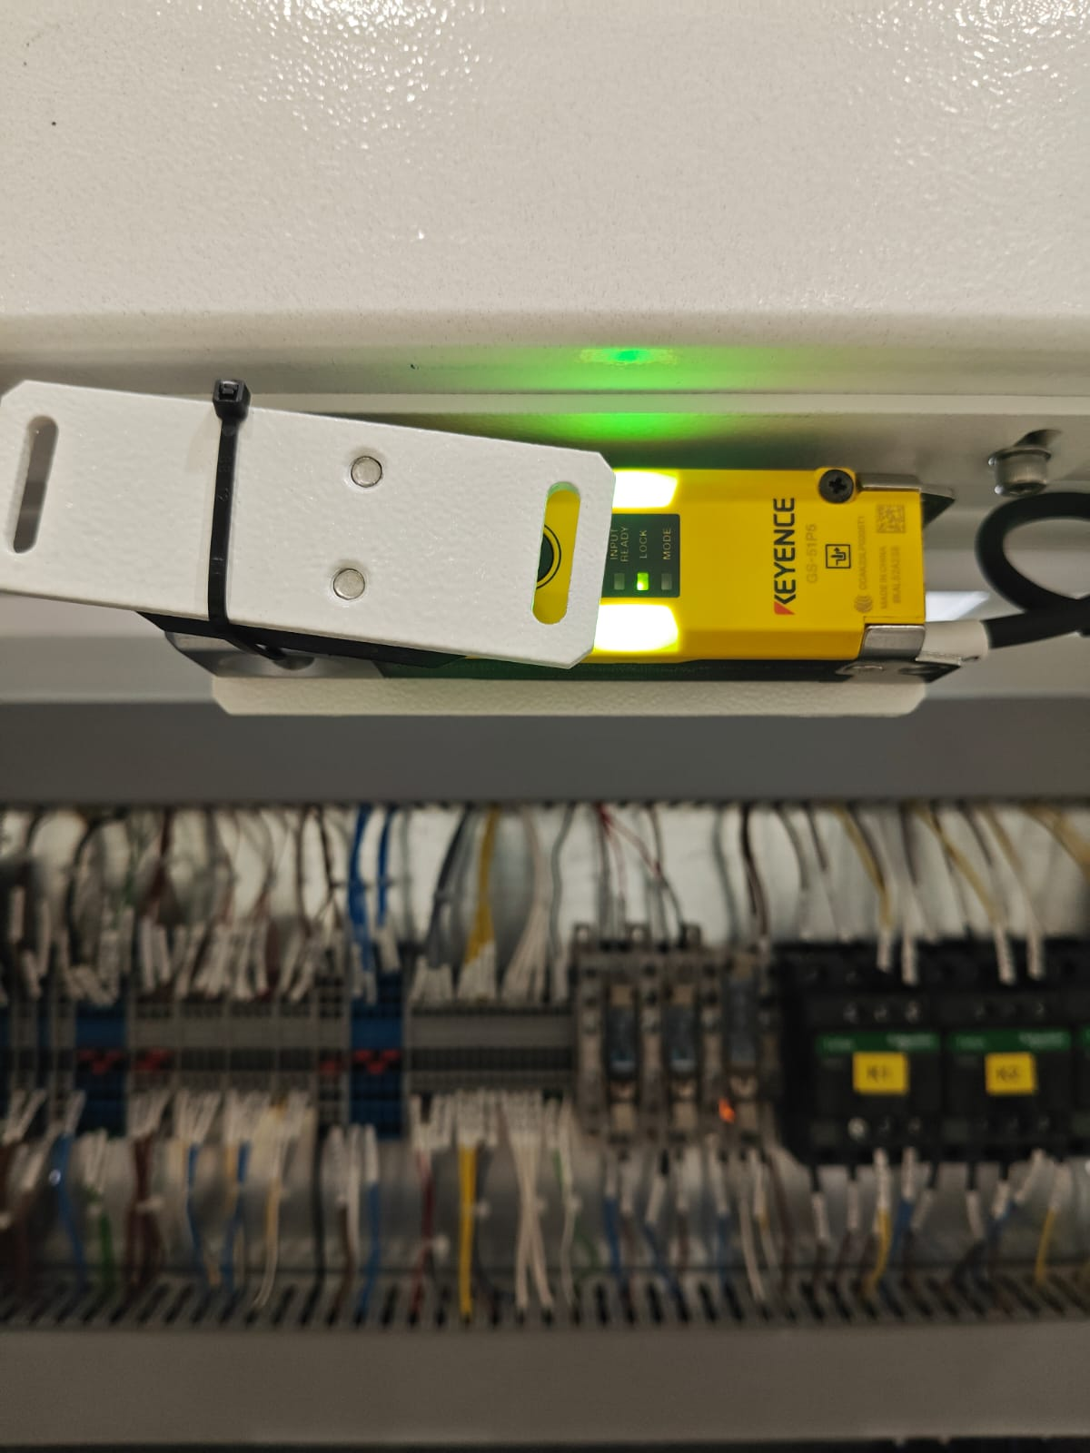

ID | Type | Brand & Model | Station | PL/Cat | Function
SD-01 | Safety door latch | Keyence GS-51P5 | S1 | PLe / Cat 4 | Interlocks S1 access door
SD-02 | Safety door latch | Keyence GS-51P5 | S2 | PLe / Cat 4 | Interlocks S2 access door
SD-03 | Safety door latch | Keyence GS-51P5 | S3 | PLe / Cat 4 | Interlocks S3 access door
SD-04 | Safety door latch | Keyence GS-51P5 | S4 | PLe / Cat 4 | Interlocks S4 access door
SD-05 | Safety door latch | Keyence GS-51P5 | S5 | PLe / Cat 4 | Interlocks S5 access door
SD-06 | Safety door latch | Keyence GS-51P5 | S6 | PLe / Cat 4 | Interlocks S6 access door
SD-07 | Safety light curtain | Keyence GL-VM39FP | S1 | PLe / Cat 4 | Area sensing at tray loading zone
SD-08 | Safety light curtain | Keyence GL-VM39FP | S6 | PLe / Cat 4 | Area sensing at tray unloading zone
SD-09 | E-stop pushbutton | Per IEC 60947-5-5 | S1 | PLd / Cat 3 | E-stop ES-01
SD-10 | E-stop pushbutton | Per IEC 60947-5-5 | S2 | PLd / Cat 3 | E-stop ES-02
SD-11 | E-stop pushbutton | Per IEC 60947-5-5 | S3 | PLd / Cat 3 | E-stop ES-03
SD-12 | E-stop pushbutton | Per IEC 60947-5-5 | S4 | PLd / Cat 3 | E-stop ES-04
SD-13 | E-stop pushbutton | Per IEC 60947-5-5 | S5 | PLd / Cat 3 | E-stop ES-05
SD-14 | E-stop pushbutton | Per IEC 60947-5-5 | S6 | PLd / Cat 3 | E-stop ES-06
SD-15 | Servo STO | Integrated in drives | All | PLd / Cat 3 | Safe Torque Off — all HIWIN and Toyo axes
SD-16 | Robot safety I/O | KUKA KR CS Box-2 | S1,S6 | PLd / Cat 3 | Robot safety stop per ISO 10218-1
SD-17 | Dual contactor | Integrated in panel | All | PLe / Cat 4 | Power removal on safety demand

11.4 Safety Interlock Logic

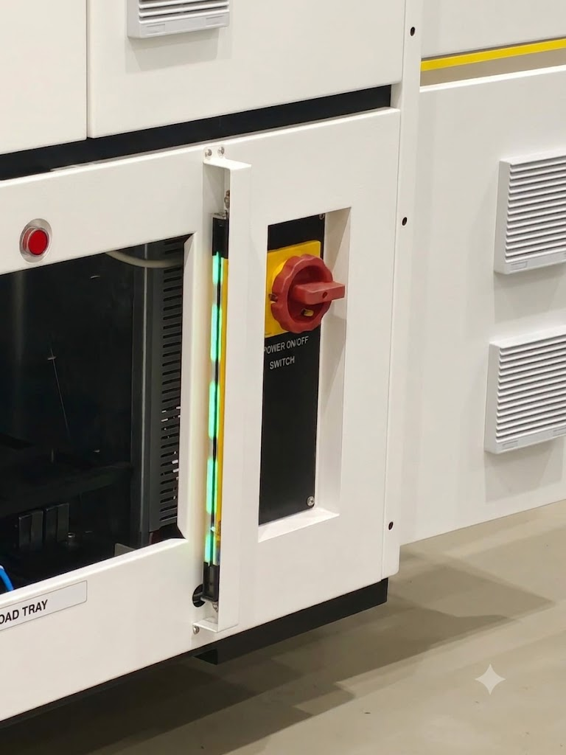

Safety Condition | Safety PLC Response | Machine Response | Restart Method
E-stop activated (any station) | STO all drives | Category 1 stop — all axes | Manual reset + IPC acknowledge
Safety door opened (any station) | STO affected station | Category 1 stop — affected station | Door closed + IPC acknowledge + manual restart
Light curtain beam broken (S1/S6) | STO to S1 or S6 | Category 1 stop — affected station | Beam cleared + IPC acknowledge + manual restart
Safety PLC fault | STO all drives | Full machine stop | Fault resolved + authorized reset
Power failure | STO by default | All drives de-energized | Full startup sequence
Robot safety I/O fault | Robot safety stop | Robot stops — other stations may continue | Robot fault resolved + IPC acknowledge

11.5 Safety Function Testing Requirements
Safety Function | Frequency | Acceptance Criteria
Safety door interlock — all doors | Weekly | Machine stops on door open; alarm displayed; no auto-restart
Safety light curtain — S1 and S6 | Weekly | Machine stops on beam break; curtain alarm; green indicator returns on clear
E-stop function — all buttons | Weekly | All axes stop; STO confirmed; IPC alarm displayed
Dual-channel door interlock integrity | Monthly | Safety PLC fault alarm within 500 ms on channel disconnect
Dual-channel light curtain integrity | Monthly | Safety PLC fault alarm within 500 ms on OSSD disconnect
STO on all servo drives | Monthly | Motor produces no torque with STO active
Robot safety stop | Monthly | Robot stops within defined deceleration time; no fault on restart
Full safety function audit | Six-monthly | All safety functions verified to stated PL and Category

11.6 Prohibited Actions
- Bypassing, defeating, or disabling any safety door interlock, light curtain, E-stop, or STO for any reason
- Entering any guarded zone without completing full LOTO (Section 4)
- Modifying Safety PLC parameters or safety circuit wiring without written authorization from Indo-MIM engineering
- Removing or covering safety warning labels on the machine
- Operating the machine with any fixed guard removed or access door open
- Using tape, cable ties, or any device to hold a safety door latch closed while the door is open
- Allowing untrained or unauthorized personnel to operate the machine in any mode
WARNING [ISO 7010 W028]
The KUKA KR13 moves at up to 2700°/s with a 13 kg payload. There is no safe distance inside the working envelope while the robot is powered. Complete LP-05 isolation — both S1 and S6 controllers — before entering. Every time.

12. COMPLIANCE & CERTIFICATIONS

12.1 International Safety Standards
Standard | Title | Relevance
ISO 12100:2010 | Safety of Machinery — Risk Assessment and Risk Reduction | Overall risk methodology — all sections
ISO 13849-1:2015 | Safety-Related Parts of Control Systems | Safety PLC, STO, interlocks, E-stop
ISO 13850:2015 | Emergency Stop Function | E-stop design — Section 5
ISO 14119:2013 | Interlocking Devices for Guards | Safety door latches — Section 11
ISO 14120:2015 | Guards — General Requirements | Fixed guard design
ISO 14118:2017 | Prevention of Unexpected Start-Up | Restart prevention — Section 11
ISO 13855:2024 | Positioning of Safeguards | Light curtain positioning
ISO 10218-1:2011 | Safety Requirements for Industrial Robots | KUKA robot integration
ISO 20607:2019 | Instruction Handbook | Manual structure
IEC 82079-1:2019 | Preparation of Instructions for Use | Signal word hierarchy
IEC 60204-1:2016 | Electrical Equipment of Machines | Panel design — Section 8
IEC 61496-1:2020 | Electro-Sensitive Protective Equipment | Light curtain spec

12.2 Indian Standards & Regulations
Standard | Title | Relevance
IS 4571:2008 | Safety of Machinery (Indian Standard) | Indian regulatory compliance — all sections
IS 12100:2012 | Safety of Machinery — General Principles (Indian adoption) | Risk assessment under Indian standards framework
Factories Act 1948 | Indian Industrial Labour Law — Section 21: Fencing of Machinery | Legal basis for machine guarding at Tata Electronics

12.3 Component-Level Standards
Component | Applicable Standard | Compliance Basis
Safety door latch (Keyence GS-51P5) | ISO 14119, IEC 60947-5-3 | Manufacturer's declaration — PLe / Cat 4 / SIL3
Safety light curtain (Keyence GL-VM39FP) | IEC 61496-1, ISO 13849-1 | Manufacturer's declaration — PLe / Cat 4 / SIL3
Safety PLC (FLX3 series) | ISO 13849-1 | Manufacturer's declaration
KUKA KR13 R850 Z200-2 CS | ISO 10218-1, IEC 60204-1 | Manufacturer's declaration — CE marked
Atlas QMC-21-10-HM4 | IEC 60745, ISO 11148 series | Manufacturer's declaration
Deprag Screw Feeder | IEC 60204-1 | Manufacturer's declaration

12.4 Compliance Statement
This manual was prepared by Certified Safety Professional, based on the Machine Safety Assessment Report (V1.1, March 2026), DFM V1.4 (March 2026), and the standards listed above. Where the machine was not available for physical inspection, gaps are documented as Open Actions — not assumed, not ignored, not filled with generic content. The Open Actions Register closes when the machine is verified, not before.
Final review and verification is the responsibility of Indo-MIM Limited as machine manufacturer and Tata Electronics as end user. All Open Actions must be closed before this manual is released as a controlled document and the machine enters production service.

12.5 Document Control
Field | Details
Document Title | Operating & Safety Manual — BG Snap Assembly Machine
Document Number | IndoMIM-BGSnap-OSM-001
Revision | V5.0
Classification | Confidential — Indo-MIM Limited / Tata Electronics
Language | English
Format | Word (.docx) — editable / PDF (.pdf) — controlled copy
Retention Period | Minimum 10 years from commissioning per Factories Act 1948
Next Review Date | Following site visit and dry run — target V5.0 final release

12.6 Customer Sign-Off
The following sign-off is required before this manual is released as a controlled document and the machine is placed into production service.
Indo-MIM Limited — Manufacturer Authorization
I confirm that this manual has been reviewed by Indo-MIM Limited's engineering and quality team, all technical content verified as accurate, and all Open Actions assigned to Indo-MIM reviewed and accepted for closure.
Name: | Designation: | Signature: | Date:

Tata Electronics — End User Authorization
I confirm that this manual has been reviewed by Tata Electronics' EHS and operations teams, all procedures are suitable for the facility's operating conditions, and all Open Actions assigned to Tata Electronics reviewed and accepted for closure.
Name: | Designation: | Signature: | Date:

Certified Safety Professional — Manual Author
I confirm that this manual has been prepared in accordance with applicable standards and professional obligations, and that all known safety gaps have been formally documented as Open Actions.
Name: | Designation: | Signature: | Date:

APPENDIX A — RESIDUAL RISK SUMMARY
The safeguards on this machine are good. They are not perfect. This appendix tells you what risk remains after everything that could be engineered has been engineered. These risks are real — they are low, but only because the people working with this machine respect the procedures.
All operators, setup technicians, and maintenance technicians must read this appendix in full before working with or near this machine.
Hazard | Control Applied | Residual Risk | Requirement
Servo axis shearing (maintenance) | Interlocked safety doors (PLe/Cat4), STO, LOTO | Low | Full LOTO per Section 4 before entering
Electrical shock — live parts (523.2V AC) | Lockable main isolator LP-01, voltage verification, LOTO | Low | Full LOTO; voltage test before panel work
Stored energy — DC bus capacitors | 60-second wait after LP-01 isolation | Low | 60-second wait mandatory — no exceptions
KUKA robot impact during operation | Fixed guarding, interlocked door, light curtain (PLe/Cat4) | Low | Light curtain must be unobstructed during operation
KUKA robot impact during maintenance | LP-04 isolation of both robot controllers | Low | Full LOTO including LP-04 before entering S1 or S6
Snap/screw feeder entanglement | Fixed guarding, interlocked access, LOTO | Low | Full LOTO before accessing feeder mechanisms
Tray lifter gravity hazard | STO on Z-axis servo; LP-01 and LP-03 required | Low | Isolate LP-01 and confirm LP-03 STO before reaching under tray lifter
Residual pneumatic pressure after LP-02 | Bleed-down via pressure gauge verification | Low | Confirm gauge at zero before reaching near pneumatic actuators
Ergonomic strain — tray loading/unloading | Operator training, correct posture guidance | Low | Use correct manual handling posture; observe tray weight limits
Unexpected restart after E-stop reset | Mandatory manual restart sequence from IPC | Low | Follow E-stop reset procedure in Section 5.4 fully
Safety door interlock bypass — Keyence GS-51P5 low-coded actuator | Keyence GS-51P5 uses basic (low) coding only. A duplicate or matching actuator can satisfy the interlock without the guard physically closed, allowing access to hazardous zones with the safety system falsely satisfied. Managed through site access controls, operator training, and periodic inspection of all actuators. | Low | Inspect actuator condition, mounting, and coding type at each safety function test. Report any unaccounted-for actuator to EHS supervisor immediately. Upgrade to higher-coded actuator (ISO 14119 Level 3/4) if bypass risk assessment warrants.
Residual pneumatic pressure — timer-activated delayed vent after LP-02 isolation | After LP-02 solenoid valve is isolated, air stored in reserve volume exhausts over time via a timed auto-vent sequence — not instantaneously. Personnel may approach before full bleed-down if they rely on elapsed time rather than gauge confirmation. | Low | Always verify pressure gauge reads 0 MPa before approaching any pneumatic actuator after LP-02 isolation. Never rely on elapsed time alone — confirm gauge reading every time without exception.

A.2 PPE Requirements
PPE Item | Required For | ISO 7010
Safety footwear (steel-capped) | All personnel at all times on shop floor | M009
Protective gloves (cut-resistant) | Maintenance technicians during LOTO and component handling | M008
Safety glasses | Maintenance during pneumatic work or component handling | M004
High-visibility vest | Any personnel entering machine access zones | —

APPENDIX B — MAINTENANCE LOG TEMPLATE
All completed maintenance tasks must be recorded below. One entry per task. Result codes: S = Satisfactory | R = Item Replaced | F = Fault Found | D = Deferred
Date | Task # | Description | Station | Result | Observations | Technician | Sign

Maintenance records must be retained by Tata Electronics for a minimum of three years per Factories Act 1948.
APPENDIX C — LOTO LOG TEMPLATE
A new entry must be made for every LOTO event without exception. Log must remain at machine at all times. Stations/Points: list all isolation points applied (e.g. LP-01, LP-02, LP-04 S1, LP-05).
Date | Time Out | Time In | Stations / Points | Reason | Technician Name | Observations | Sign

